Works Subject to Copyright:

“Copyright protection subsists, in accordance with this title, in original works of authorship fixed in any tangible medium of expression, now known or later developed” 17 U.S. Code § 102

• Literary works
• Musical works, including any accompanying words
• Dramatic works, including any accompanying music
• Pantomimes and choreographic works
• Pictorial, graphic, and sculptural works
• Motion pictures and other audiovisual works
• Sound recordings, which are works that result from the fixation of a series of musical, spoken, or other sounds
• Architectural works

Works Not Subject to Copyright:

• Idea, procedure, process, system, method of operation, concept, principle, or discovery;
• Words and short phrases such as names, titles, and slogans;
• Familiar symbols or designs;
• Mere variations of typographic ornamentation, lettering or coloring;
• Mere listing of ingredients or contents;
• Works created by the U.S. federal government;
• Some useful articles, such as fashion, furniture, food, clothing, whitepages, buildings finished before 1990;
• Merger;
• Scènes à faire.

Duration of Copyright Protection:

- 1790 Act: 14+14; 1831 extension: 28+14
- 1909 Act: 28+28
  - 1976 extension: 28+47
  - 1998 extension: 28+67 (~1977)
  - 1992: auto renewal (1965~ )
- 1976 Act: Life+50
  - 1988: copyright notice no longer required
  - Sonny Bono Act: Life+70

The length of a copyright depends on when the work was created, published, and/or registered. Duration also depends on whether the work was created by an individual, more than one individual, or as an employee or at the direction of another person or company. For works created by individual authors on or after January 1, 1978, copyright protection begins at the moment of creation and lasts for a period of 70 years after the author's death. In the case of "a joint work" (prepared by two or more authors) the term lasts for 70 years after the last surviving author's death. For works made for hire, and for anonymous and pseudonymous works, copyright protection generally lasts for 95 years from publication or 120 years from creation, whichever is shorter.

For works created before January 1, 1978 (protected under the 1909 Copyright Act), the duration rules are quite different (and much more complex). Duration depends on a number of factors, including whether the work was "published" and whether or not the copyright was renewed. In general, under the 1909 Copyright Act, copyright protection begins with first publication of the work and lasts for a period of 28 years, renewable for an additional term of 28 years, for a total term of protection of 56 years. In 1976, Congress extended the renewal term to 47 years, increasing the total possible term of protection to 75 years. In 1998, Congress again extended the renewal term by an additional 20 years, for total possible term of protection of 95 years from publication.

For works created but not published or registered by January 1, 1978, copyright lasts for a period of 70 years after the author's death (or at least through December 31, 2002). For these works, if published on or before December 31, 2002, the term of copyright lasts through December 31, 2047.

A copyright holder has the exclusive right to:

• Reproduce the work in copies or phonorecords
• Prepare derivative works based upon the work
• Distribute copies or phonorecords of the work to the public by sale or other transfer of ownership or by rental, lease, or lending
• Perform the work publicly if it is a literary, musical, dramatic, or choreographic work; a pantomime; or a motion picture or other audiovisual work
• Display the work publicly if it is a literary, musical, dramatic, or choreographic work; a pantomime; or a pictorial, graphic, or sculptural work. This right also applies to the individual images of a motion picture or other audiovisual work.
• Perform the work publicly by means of a digital audio transmission if the work is a sound recording
• Authorize others to exercise these exclusive rights, subject to certain statutory limitations.

User’s rights:

- Fair use (17 U.S.C. § 107) allows certain uses of copyrighted material without permission from the copyright holder. There are four factors to consider when determining whether your use is a fair one. You must consider all the factors, but not all the factors have to favor fair use for the use to be fair.
The four fair use factors are
- the purpose and character of the use, including whether such use is of a commercial nature or is for nonprofit educational purposes;
- the nature of the copyrighted work;
- the amount and substantiality of the portion used in relation to the copyrighted work as a whole; and
- the effect of the use upon the potential market for or value of the copyrighted work.
Fair use favors “purposes such as criticism, comment, news reporting, teaching (including multiple copies for classroom use), scholarship, [and] research.” While many uses for educational purposes are fair, not all are. You need to evaluate your use each time you are reproducing copyrighted material — to show in your class, to hand out copies, to include in your writing, or to post on your course website.
- Teachers and students can make certain uses of copyrighted works in face-to-face teaching. As a teacher or student, you are allowed to perform or display a copyrighted work without permission in “a classroom or similar place devoted to instruction” during face-to-face teaching at a nonprofit educational institution. If the work is a motion picture or other audiovisual work, you must use a copy of the work that was lawfully made.

Creative Commons Licenses:

This license lets others distribute, remix, tweak, and build upon your work, even commercially, as long as they credit you for the original creation. This is the most accommodating of licenses offered. Recommended for maximum dissemination and use of licensed materials.
This license lets others remix, tweak, and build upon your work even for commercial purposes, as long as they credit you and license their new creations under the identical terms. This license is often compared to “copyleft” free and open source software licenses. All new works based on yours will carry the same license, so any derivatives will also allow commercial use. This is the license used by Wikipedia, and is recommended for materials that would benefit from incorporating content from Wikipedia and similarly licensed projects.
This license allows for redistribution, commercial and non-commercial, as long as it is passed along unchanged and in whole, with credit to you.
This license lets others remix, tweak, and build upon your work non-commercially, and although their new works must also acknowledge you and be non-commercial, they don't have to license their derivative works on the same terms.
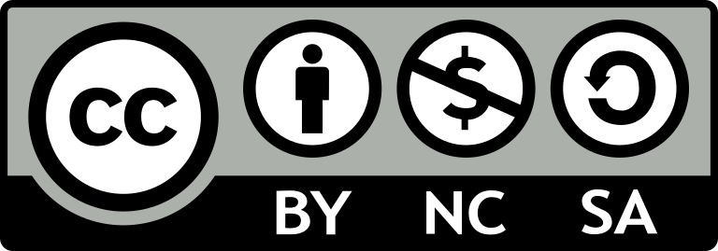
This license lets others remix, tweak, and build upon your work non-commercially, as long as they credit you and license their new creations under the identical terms.
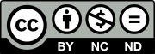
This license is the most restrictive of the six main licenses, only allowing others to download your works and share them with others as long as they credit you, but they can’t change them in any way or use them commercially.
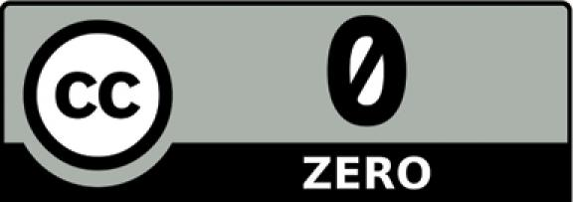
Creative Commons offers a Public Domain Dedication, known as CC0. You can use CC0 to waive your copyright in a work.

Substantial Similarity:
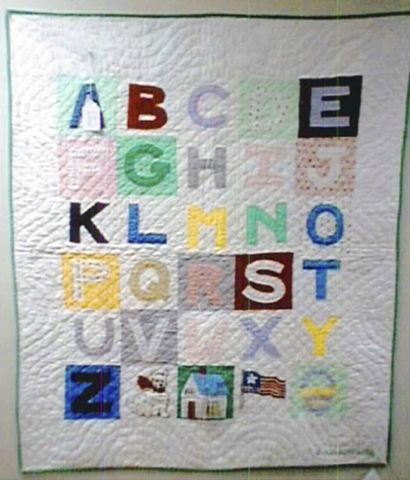
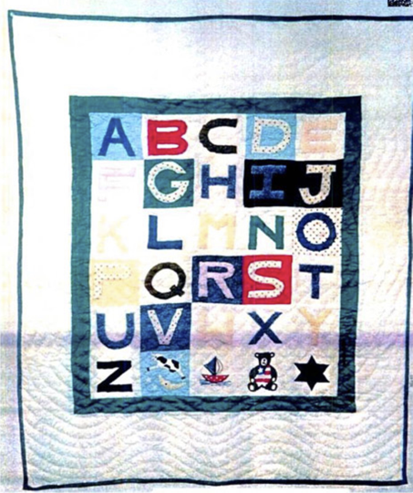
The Second Circuit found these to be substantially similar because of:
1. The groupings of blocks in each row
2.Use of contrasting solid color fabrics or solid and polka-dotted fabrics
3.Similar colors associated with each letter
4.Unique shapes of "J," "M," "N," "P," "R,” “W”
5.Diamond-shaped quilting within the blocks and a ‘wavy’ pattern in the plain white border that surrounds the blocks
6.Edged with a 3/8" green binding
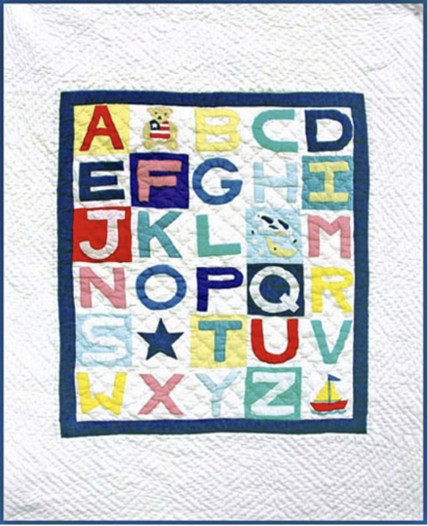

- The quilt on the left does not have its four icons in the last row.
  - The teddy bear with the flag vest is placed after the "A" in the first row.
  - The cow jumping over the moon is placed after the "L" in the third row.
  - The star is placed after the "S" in the fifth row.
  - The sailboat is placed after the "Z" in the last row.
- The colors chosen to represent the letters and the blocks are, for the most part, entirely different.
  - The left one did not use any polka-dot fabric.
- The quilting pattern in the plain white border is changed to a "zig-zag," as opposed the "wavy" design.
- The binding around the edge is blue instead of green.

