StoneSoup: A Community driven Proactive Display

We are the copyright holder(s) of this submission and related materials. We grant the University of Michigan University Library non-exclusive rights to develop designs outlined by competition entry submissions in any and all media, for non-commercial library purposes, with attribution to us.

Abstract
Proactive displays facilitate interaction and increase awareness in collocated communities. In this paper, we present a community driven proactive display system that allows its users to personalize content for the display. The system is designed to support the creation, appropriation, and discovery of content over different settings of appearance, social context and time. In addition, the system offers multiple ways of interacting with the content. Our main contributions in this work are the designs for content discovery, appropriation and reconfiguration in a collaborative system.

Gaurav Paruthi

School of Information,
University of Michigan
105 South State Street,
Ann Arbor, MI 48104, USA
gparuthi@umich.edu

Chuan-Che Huang

School of Information,
University of Michigan
105 South State Street,
Ann Arbor, MI 48104, USA
chuanche@umich.edu

Faculty Advisor:

Mark W. Newman

School of Information,
University of Michigan
105 South State Street,
Ann Arbor, MI 48104, USA
mwnewman@umich.edu

Author Keywords
Proactive displays, interactive public displays, collaborative configuration

General Terms
Design, Human Factors

Web Page:

StoneSoup Intro

Video Link
http://www.youtube.com/watch?v=Nd1xIIDM8Mk

Introduction
Public displays are ubiquitous in our everyday life. From restaurants to airports, these displays serve many different social and temporal contexts. Adding sensors to these displays make them proactive and may even detect nearby people for displaying personalized content. An interesting subset of such displays is the community display system, which serves the needs of a collocated community. Research on community displays has focused on interpersonal awareness, social relationships, and media sharing around such displays. Researchers have provided many design guidelines and highlighted the importance of the community in the success of such systems [1,3].
In this work, we leverage existing research to design and build a community driven proactive display system called StoneSoup. The system is primarily designed for community building by increasing collaboration and awareness in a shared space. Towards this goal, StoneSoup collectively aggregates the content generated by the users in the space, based on each individual’s preference. The design of StoneSoup heavily draws upon the findings and design principles articulated in existing research. We discuss these briefly in the following paragraphs. In addition we present novel designs for the appropriation, discovery and reconfiguration of content that has not been studied in detail yet.
Proactive displays serve a broad range of design goals, which are based on the context of their deployment. Some goals like enhancing communities and managing privacy are shared across all contexts. Other design principles are specific to the context. Context related applications of proactive displays have shown to succeed in increasing social interaction in conferences [7], social spaces in work environment [1,5] and in cafés [6].
More paper prototypes here: https://googledrive.com/host/0BzEABVphXJi6QklFZG1uVk9yZzg/PaperPrototype1.pdf

Enabling the community to contribute content is an important design principle for increasing interaction in a community [1,3,5,6,7,8]. Attributing the shared content to its creator is a good way of felicitating these interactions and increase social information flow [1]. Community generated content also requires the proactive display system to manage the content along the dimensions of privacy, nomination and presentation [2]. We incorporate these design principles in our design of the StoneSoup system. In the following sections we highlight the main contribution of our work and our design process.

Design Process
We designed StoneSoup iteratively:

1. Initial paper prototyping and evaluation
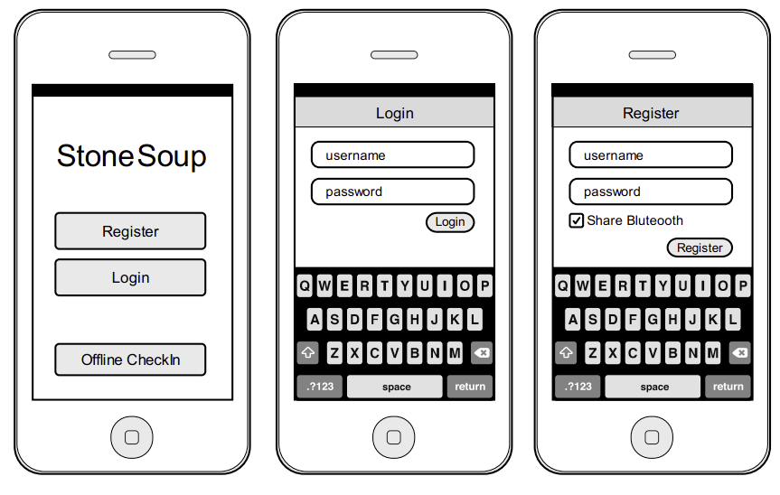
We used paper prototyping technique to come up with the initial designs for our renderer and mobile application.

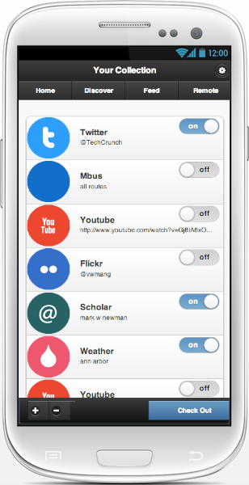
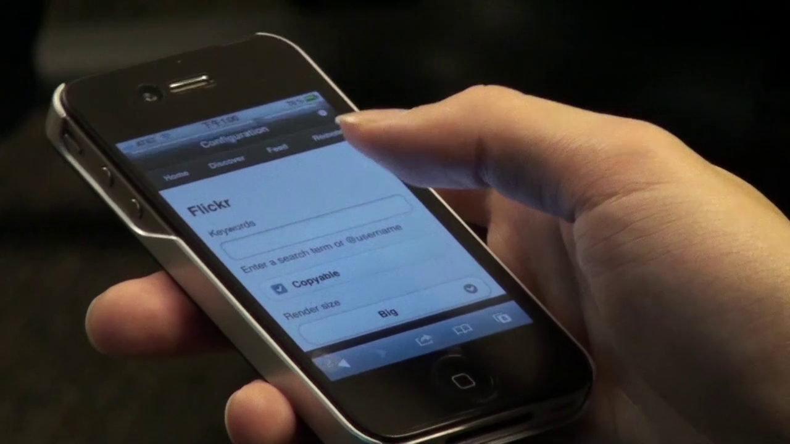
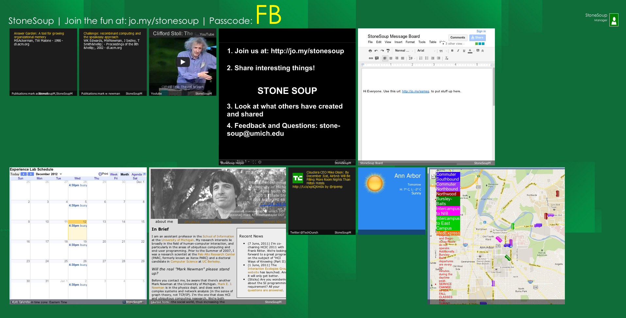
2. Hi-fi prototyping (v0.1 & v0.2)
Figure 2. The mobile application interface shows the widgets of a user. Bottom right button is used for check-in and check-out.
Figure 3. A widget can be created on the mobile UI.
Figure 1. The StoneSoup Display provides a tiles based view for the widgets. The checked-in users are shown on the top-right of the display. Widget allows interactivity via the mobile application and Kinect sensors.
Since the concept of StoneSoup is a novel one, we decided that building a Hi-Fi prototype and deploying it would be the best way to go ahead with building StoneSoup.

3. User study (deployment at phd office)
We deployed the first version of StoneSoup in the Ph.D. space and found that the system could use many new features and a streamlined interface for easier use.

4. Video prototyping
Video prototypes helped us to explain the concept of StoneSoup to our intended audience.
Video prototype can be found here:
http://www.youtube.com/watch?v=Nd1xIIDM8Mk

5. Hi-Fi Prototype 2.0
We built the second version of StoneSoup from ground up to implement an interface which is much faster, allows many features and is flexible enough to add newer features.

6. Focus Group Evaluation
Focus group evaluation was used to evaluate the Hi-Fi prototype

Design
The design of the StoneSoup system builds itself upon the PROD framework [2]. On a higher level it consists of- an interface over which a user interacts with the system; a display embedded with sensors for detecting presence and gestures; and a backend server to support these. An important design goal of our work was to democratize the control of content to users. This requires designs for the UI that support the creation, appropriation and reconfiguration of content. In the following paragraphs we briefly discuss some of the important aspects of this.

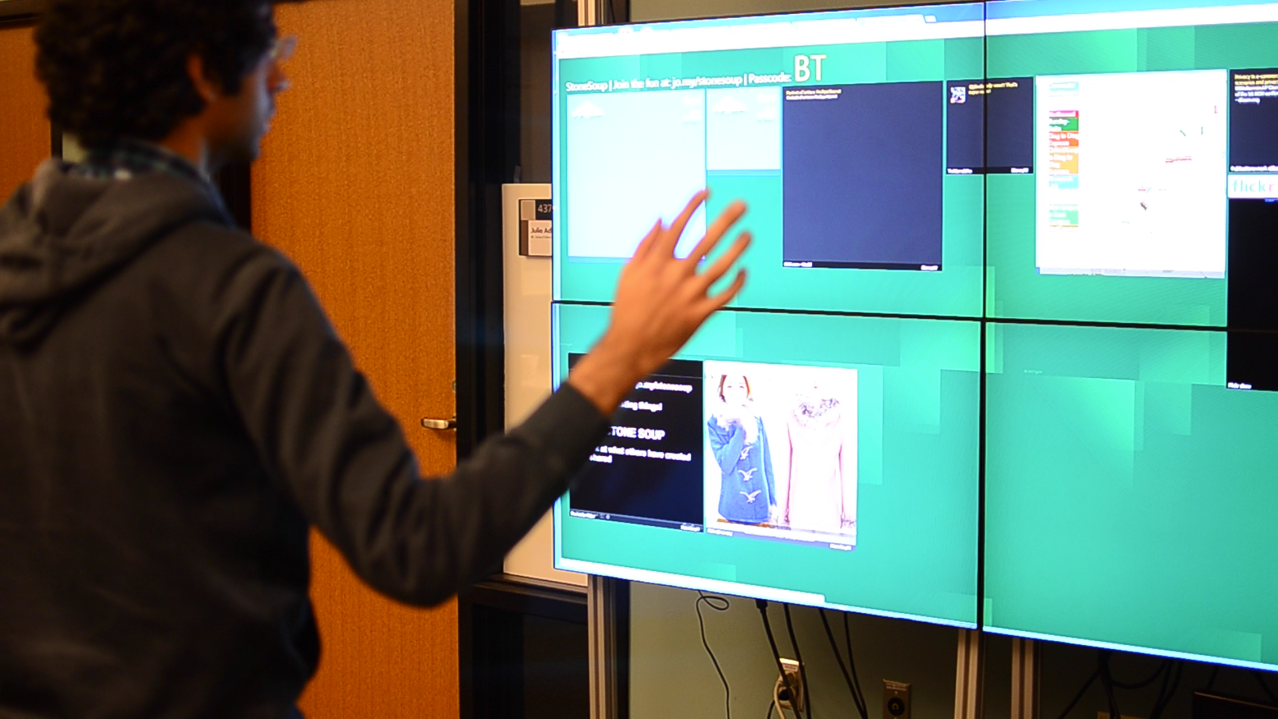
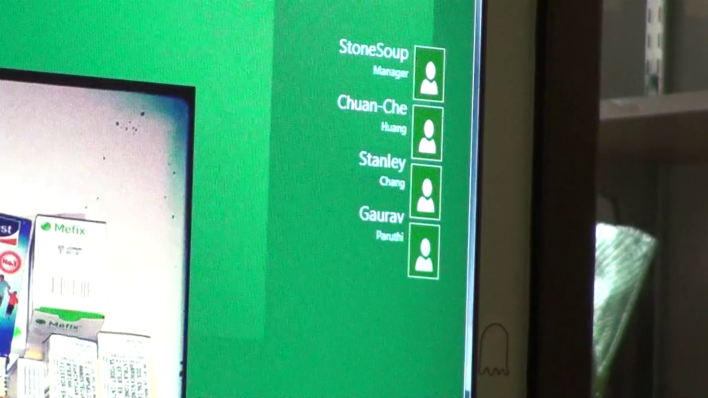
Content Creation
Figure 4. StoneSoup lets users to interact with the system via gestures identified by Kinect.
Figure 5 Nearby Users being displayed on the top right corner of the screen.
Previous studies have supported the creation of content by using simple forms to present content from online media sources [5] and user generated media [1]. We extend these designs to fit our implementation of the proactive display system. The user interacts with our system via the StoneSoup web application accessible from multiple computing interfaces (mobiles, desktops and tablets.) The created content can be configured over multiple dimensions of social context [2], content, time, and layout.

Content Appropriation
An important aspect for making usable collaborative systems is to ease users’ burden in creating content. Supporting the appropriation of existing content is a good way to do this, and is one of our contributions in this work. It is also essential that these mechanisms be designed for users with no programming experience [4]. The appropriation of content requires three reconfiguring it and then publishing the content.

Content Discovery
Users discover content shared on proactive displays in two ways. First, they can directly observe content shared on the display and then choose to appropriate. For this our design embeds the identification of content and its attribution along with the content displayed on the display. Secondly, they can discover content by browsing through the web interface of the system. We provide intuitive features to support both these scenarios.

Reconfiguring Content
We have designed the UI for content reconfiguring and publishing to closely match the UI for content creation. It allows the use of existing content created by other users and let users modify it as if they were creating new content without the need for setting all its input parameters and context rules from scratch.

Appropriation as information staging
Appropriating content for community displays can be seen as “information staging” [1], where the display is a public stage on which each user is represented by the content they share. Our design for the appropriation of content supports this aspect and tries to prevent unintended representations. The user interface provides a “backstage” feature that allows users to test widgets on their local system before sharing it with the community. Users can create their set of widgets and then press the Backstage button. Users can appropriate and reconfigure their widgets

Implementation
StoneSoup consists of three main modules: The web interface is coded in HTML and Ajax, the backend in Python, and the display renderer in HTML, Javascript and it utilizes WebSockets for instant updating. All parts of the system have been programmed in a modular manner to support extensibility in the sensors, displays, clients and features. The prototype display is currently deployed in the student space on a 2560x1440 resolution display, with its backend server hosted on Amazon EC2.
Before StoneSoup can show personalized content, users first need to register and appropriate content using the mobile web interface for StoneSoup. The display utilizes Bluetooth sensors for detecting nearby users (Figure 1). In addition, users can manually tell the system that they are nearby. StoneSoup fetches the content and configuration of registered nearby users from the backend, and then displays it on the screen. In the rest of this section we highlight the implementation of our designs.

Content Creation and Appropriation
Figure 6 Study Lounge at the Shapiro Undergraduate library. Notice the many public displays.
Photo taken and modified from http://www.lib.umich.edu/berts-cafe-study-lounge
Users can create and appropriate widgets they would like to see when they are around a display (Figure 1). The mobile web interface allows users to easily add and configure these widgets (Figure 2). We utilize multiple APIs provided by online services to allow users to display content of their interest. Each type of widget can be configured in the content that’s being displayed; the appearance of the widget; the time and social context of when the widget should be visible.

Real-time Interactions
The StoneSoup system detects postures, gestures and other events to allow multiple ways of interacting with the system. The system is flexible in its design for allowing the addition of new sensors and to be deployed in multiple locations simultaneously. Users can use Kinect gestures like left and right swipe for browsing through multiple widget screens (Figure 4). Moreover, users can activate the widgets on the display by using the mobile app and then control them via the web app or by using other physical gestures. For instance, users can play or pause content using the web app.

MLibrary Deployment
Although we believe StoneSoup could be used in a variety of contexts, in this section we would like to focus on its use in the library.
The users of this system would be anyone in the library. For deploying StoneSoup, the study lounge in a library would be an ideal place as it is meant for people to freely interact with each other (Figure 6).
A library is the home of knowledge and an ideal environment for sharing knowledge. It would be valuable for users in the library to read and share what they have read. Moreover, people should also be able to tell others what they would like to read. Sharing this information would be a non-intrusive way of asking and offering book (or content) recommendations. It would encourage social interaction among nearby users and lead to more knowledge discovery among people.
In addition, we think that the Library can come alive through the system by informing users of where the information of interest is located. It might be a book located in some corner of the library or a web blog.

Conclusion
Proactive displays are increasingly becoming pervasive. In this work we presented a community driven proactive display system called StoneSoup that aggregates content from its users. By leveraging existing literature, we believe that StoneSoup would allow its users to easily create and share content for increased interaction and awareness within the community. More importantly, our designs related to the appropriation of content are an important contribution towards collaborative systems in general.

Note
The title of the paper- “StoneSoup” is taken from the folk tale of the same name. The tale is an inspiration for encouraging contribution by the community for the greater good [9].

Acknowledgements
We thank all those who helped in making the video and reviewing the paper.

References
1. Churchill, E.F., Nelson, L., Denoue, L., Helfman, J., and Murphy, P. Sharing multimedia content with interactive public displays: a case study. Proc. of DIS 2004. 7–16.
2. Congleton, B., Ackerman, M.S., and Newman, M.W. The ProD framework for proactive displays. Proc. of UIST 2008. 221–230.
3. Greenberg, S. and Rounding, M. The notification collage: posting information to public and personal displays. Proc. of CHI 2001. 514–521.
4. MacLean, A., Carter, K., Lövstrand, L., and Moran, T. User-tailorable systems: pressing the issues with buttons. Proc. of CHI 1990. 175–182.
5. McCarthy, J.F., Congleton, B., and Harper, F.M. The context, content & community collage: sharing personal digital media in the physical workplace. Proc. of CSCW 2008. 97–106.
6. McCarthy, J.F., Farnham, S.D., Patel, Y., et al. Supporting community in third places with situated social software. Proc. of C&T 2009. 225–234.
7. McCarthy, J.F., McDonald, D.W., Soroczak, S., Nguyen, D.H., and Rashid, A.M. Augmenting the social space of an academic conference. Proc of CSCW 2004. 39–48.
8. Nacenta, M.A., Jakobsen, M.R., Dautriche, R., et al. The LunchTable: a multi-user, multi-display system for information sharing in casual group interactions. Proceedings of the 2012 International Symposium on Pervasive Displays, ACM (2012), 18:1–18:6.
9. Stone soup. Wikipedia, the free encyclopedia, 2012. http://en.wikipedia.org/w/index.php?title=Stone_soup&oldid=527797409.

