ACTIVITY SHEET

OBJECTIVE: You should be able to understand the results of the in-class search.

INSTRUCTIONS: Based on the search that we have done together in class, please answer the following questions about the Mirlyn record below.

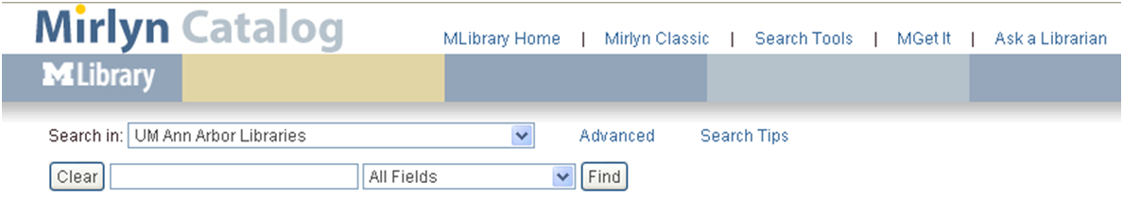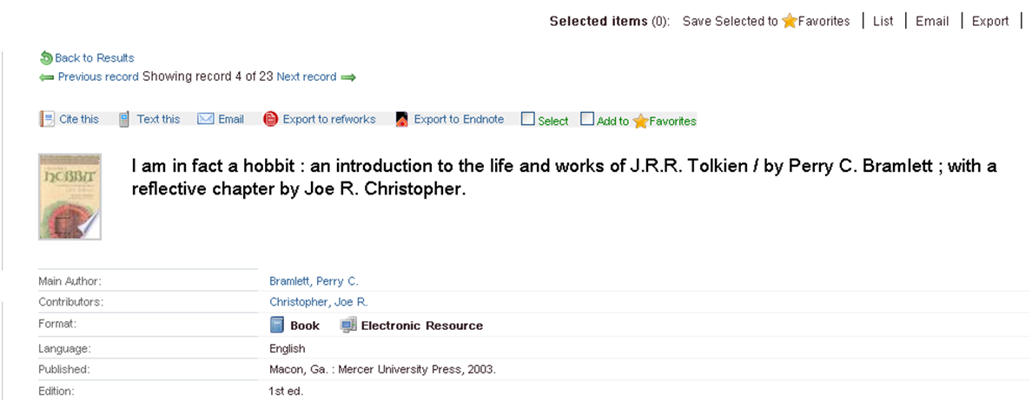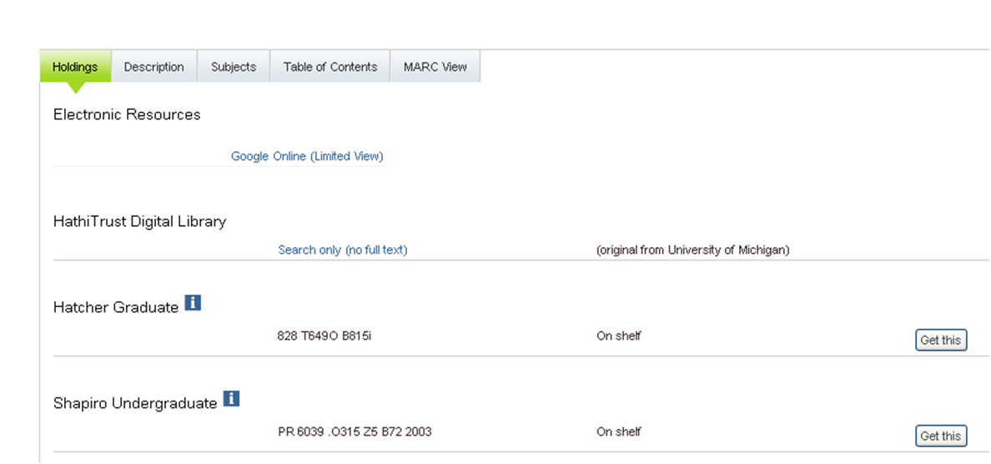

1. Place a triangle (∆) next to the location(s) of the item.

2. Circle the call number(s) of the item.

3. Place an asterisk (*) next to each status of the item.

4. Can this item be checked out? Circle yes / no.

5. Place an arrow (→) next to the type(s) of item this is, such as book, journal, video, etc.
6. Is this item available in full text online? Circle yes / no.
7. What does the “Get this” button do? ___________________________________________________________

